**SMTP Setup for Mail using ASP / PHP**

1. Install SMTP onto the server.
2. From IIS Manager right click SMTP Virtual Server and choose Properties from the drop down menu.
3. From the properties choose the Access Tab and click the Relay Button.

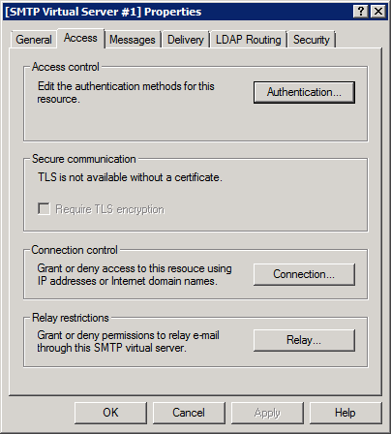

1. From the Relay Restrictions dialog check “Only the list below” and add 127.0.0.1 and the IP of the machine. Then click OK.

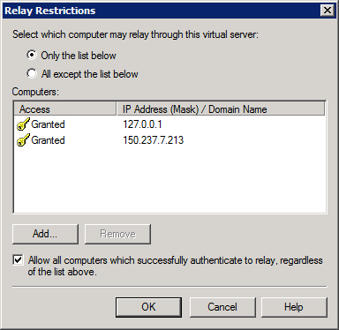

1. From the properties choose the Delivery Tab and click Advanced at the bottom of the screen.

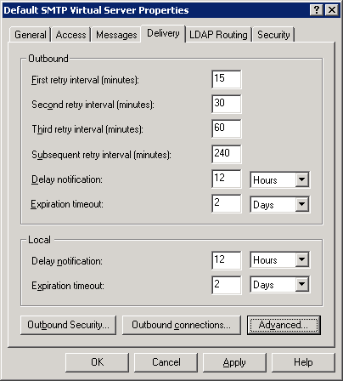

1. Finally add to the Smart host option mservers.hull.ac.uk.

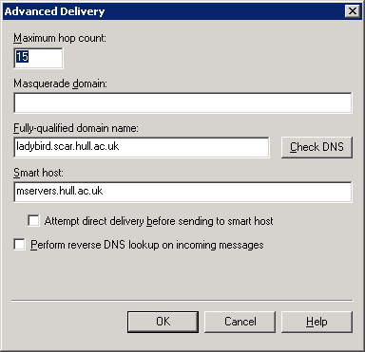

1. Click the OK button exit out of the Properties windows.

Notes:

1. The server IP address must be registered with hull to allow mservers.hull.ac.uk to accept connections from this server.
2. The Antivirus software must allow port 25 connections.
3. The PHP.ini file needs setting with a sendmail_from address.

**Change Date Format of MSSQL DB**

1. ­­­Open MSSQL Studio Management Server
2. Run the following Query on each database you want to change the date settings for.

SET DATEFORMAT dmy

1. The database will now run with the correct date time settings for UK.

Please note this will only change the date format for the query you are running. To change it for all times, change the settings below:

1. Open MSSQL Studio Management Server
2. Open the Security branch of the tree, and then the Logins branch.
3. Right-click the username of the user you want to change and click properties.

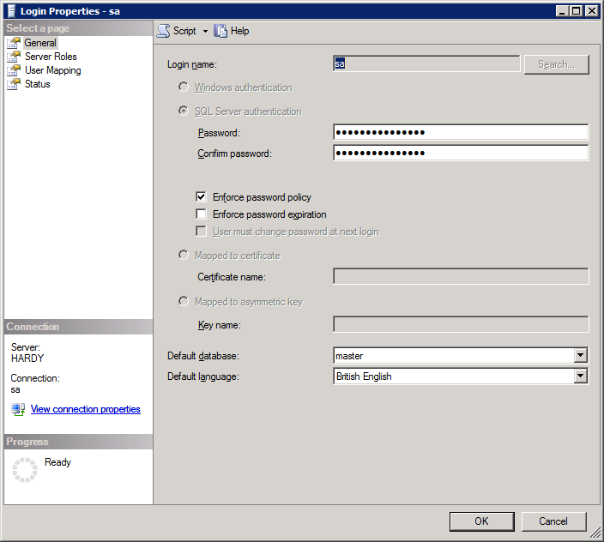

1. Change Default Language to British English.
2. Restart the server.

­­­­­